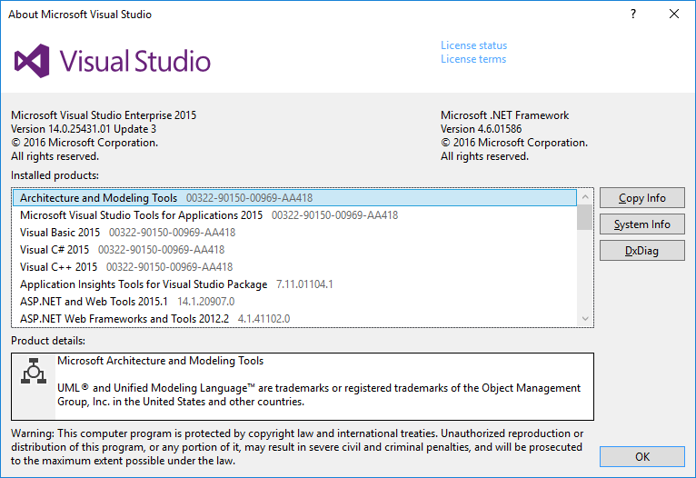

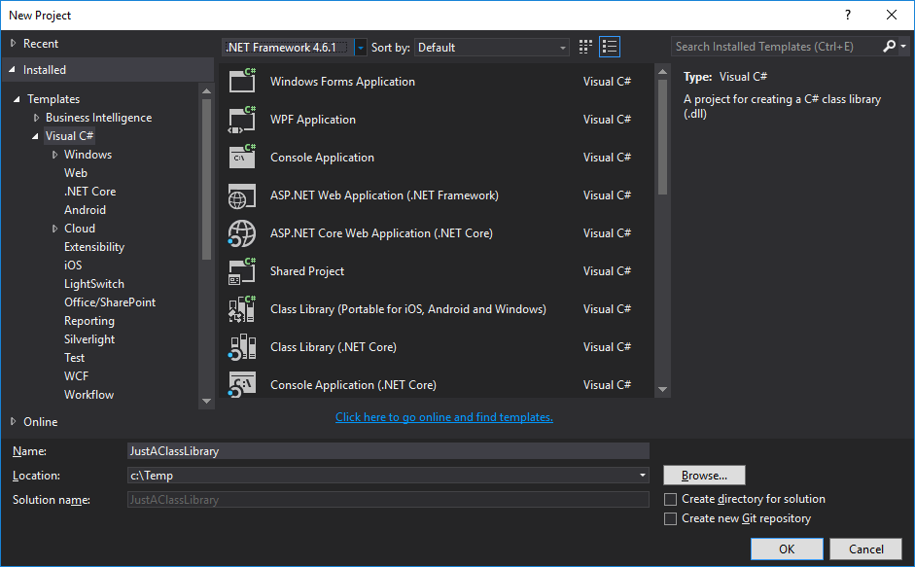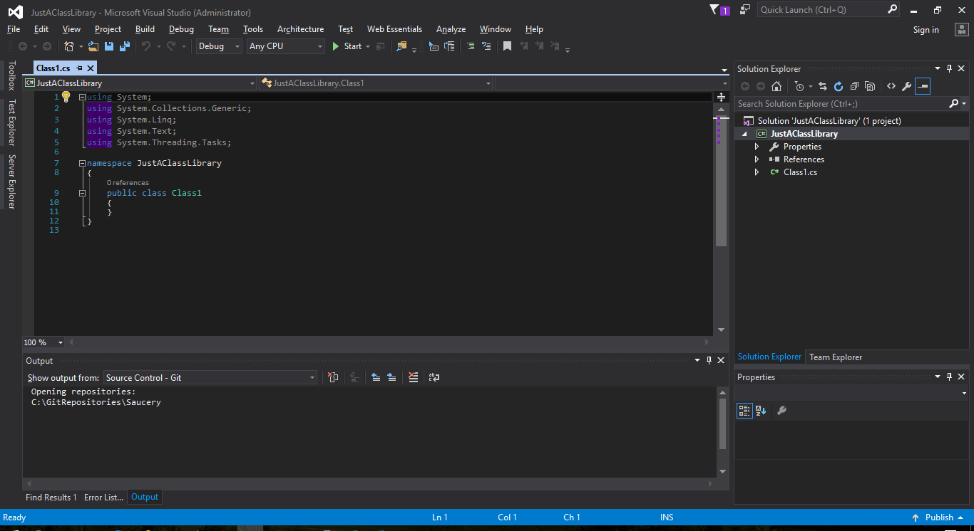

Save All

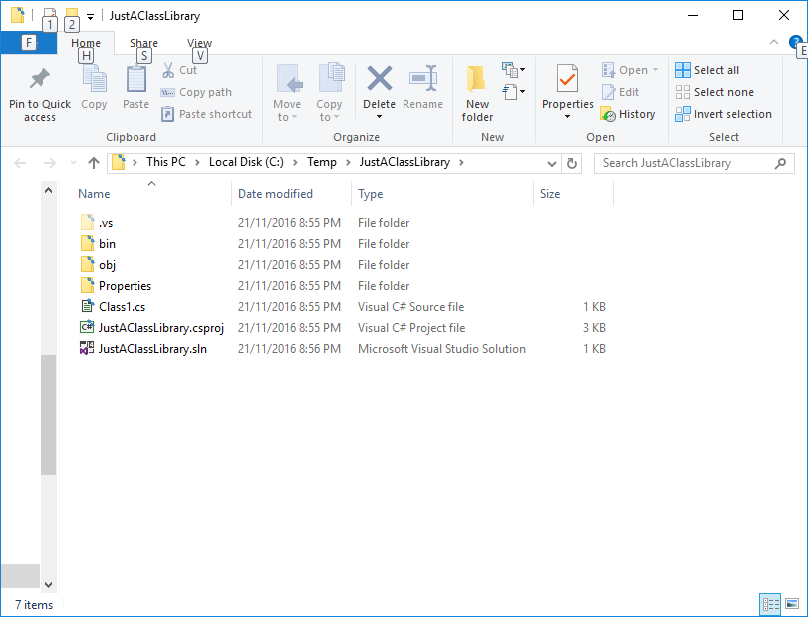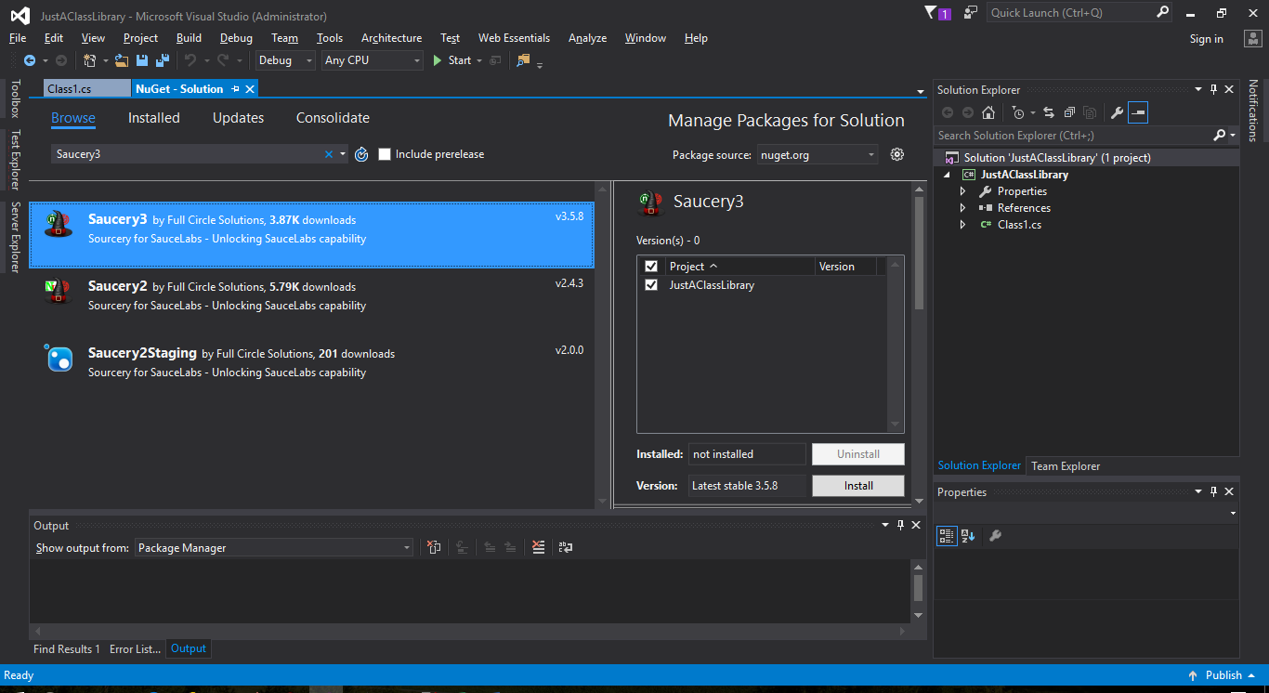

Click Install

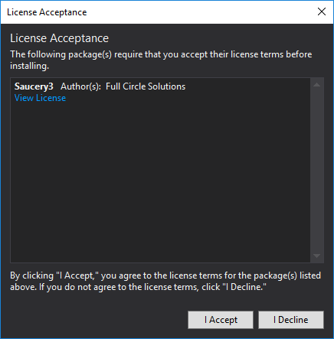

Output Window:

Attempting to gather dependency information for package 'Saucery3.3.6.1' with respect to project 'JustAClassLibrary', targeting '.NETFramework,Version=v4.6.1'

Gathering dependency information took 1.58 min

Attempting to resolve dependencies for package 'Saucery3.3.6.1' with DependencyBehavior 'Lowest'

Resolving dependency information took 0 ms

Resolving actions to install package 'Saucery3.3.6.1'

Resolved actions to install package 'Saucery3.3.6.1'

Retrieving package 'Appium.WebDriver 2.0.1.1' from 'nuget.org'.

Retrieving package 'Shouldly 2.8.2' from 'nuget.org'.

Retrieving package 'Selenium.WebDriver 3.0.0' from 'nuget.org'.

Retrieving package 'Selenium.Support 3.0.0' from 'nuget.org'.

Retrieving package 'Castle.Core 3.3.3' from 'nuget.org'.

Retrieving package 'NUnit 3.6.0' from 'nuget.org'.

Retrieving package 'Saucery3 3.6.1' from 'nuget.org'.

Retrieving package 'Newtonsoft.Json 9.0.1' from 'nuget.org'.

Retrieving package 'RestSharp 105.2.3' from 'nuget.org'.

GET https://api.nuget.org/packages/saucery3.3.5.8.nupkg

OK https://api.nuget.org/packages/saucery3.3.5.8.nupkg 235ms

Installing Saucery3 3.5.8.

Adding package 'Castle.Core.3.3.3' to folder 'c:\Temp\JustAClassLibrary\packages'

Added package 'Castle.Core.3.3.3' to folder 'c:\Temp\JustAClassLibrary\packages'

Added package 'Castle.Core.3.3.3' to 'packages.config'

Successfully installed 'Castle.Core 3.3.3' to JustAClassLibrary

Adding package 'Newtonsoft.Json.9.0.1' to folder 'c:\Temp\JustAClassLibrary\packages'

Added package 'Newtonsoft.Json.9.0.1' to folder 'c:\Temp\JustAClassLibrary\packages'

Added package 'Newtonsoft.Json.9.0.1' to 'packages.config'

Executing script file 'c:\Temp\JustAClassLibrary\packages\Newtonsoft.Json.9.0.1\tools\install.ps1'...

Successfully installed 'Newtonsoft.Json 9.0.1' to JustAClassLibrary

Adding package 'NUnit.3.6.0' to folder 'c:\Temp\JustAClassLibrary\packages'

Added package 'NUnit.3.6.0' to folder 'c:\Temp\JustAClassLibrary\packages'

Added package 'NUnit.3.6.0' to 'packages.config'

Successfully installed 'NUnit 3.5.0' to JustAClassLibrary

Adding package 'RestSharp.105.2.3' to folder 'c:\Temp\JustAClassLibrary\packages'

Added package 'RestSharp.105.2.3' to folder 'c:\Temp\JustAClassLibrary\packages'

Added package 'RestSharp.105.2.3' to 'packages.config'

Successfully installed 'RestSharp 105.2.3' to JustAClassLibrary

Adding package 'Selenium.WebDriver.3.0.0' to folder 'c:\Temp\JustAClassLibrary\packages'

Added package 'Selenium.WebDriver.3.0.0' to folder 'c:\Temp\JustAClassLibrary\packages'

Added package 'Selenium.WebDriver.3.0.0' to 'packages.config'

Successfully installed 'Selenium.WebDriver 3.0.0' to JustAClassLibrary

Adding package 'Selenium.Support.3.0.0' to folder 'c:\Temp\JustAClassLibrary\packages'

Added package 'Selenium.Support.3.0.0' to folder 'c:\Temp\JustAClassLibrary\packages'

Added package 'Selenium.Support.3.0.0' to 'packages.config'

Successfully installed 'Selenium.Support 3.0.0' to JustAClassLibrary

Adding package 'Appium.WebDriver.2.0.1.1' to folder 'c:\Temp\JustAClassLibrary\packages'

Added package 'Appium.WebDriver.2.0.1.1' to folder 'c:\Temp\JustAClassLibrary\packages'

Added package 'Appium.WebDriver.2.0.1.1' to 'packages.config'

Successfully installed 'Appium.WebDriver 2.0.1.1' to JustAClassLibrary

Adding package 'Shouldly.2.8.2' to folder 'c:\Temp\JustAClassLibrary\packages'

Added package 'Shouldly.2.8.2' to folder 'c:\Temp\JustAClassLibrary\packages'

Added package 'Shouldly.2.8.2' to 'packages.config'

Successfully installed 'Shouldly 2.8.2' to JustAClassLibrary

Adding package 'Saucery3.3.5.8' to folder 'c:\Temp\JustAClassLibrary\packages'

Added package 'Saucery3.3.5.8' to folder 'c:\Temp\JustAClassLibrary\packages'

Added package 'Saucery3.3.5.8' to 'packages.config'

Executing script file 'c:\Temp\JustAClassLibrary\packages\Saucery3.3.5.8\tools\init.ps1'...

GAC Version Location

--- ------- --------

False v4.0.30319 C:\Temp\JustAClassLibrary\packages\Saucery3.3.5.8\lib\net461\Saucery3.dll

Checking Saucery3 Activation...

Note Activation dialog does not come up yet.

Save All.

Either: View > Other Windows > Package Manager Console

Or: Save All, Close and Reopen Solution, View > Other Windows > Package Manager Console

Package Manager Console Output:

GAC Version Location

--- ------- --------

False v4.0.30319 C:\Temp\JustAClassLibrary\packages\Saucery3.3.5.8\lib\...

Checking Saucery3 Activation...

